BETHANY HOMES #B
Texas Medical Center / NRG Stadium

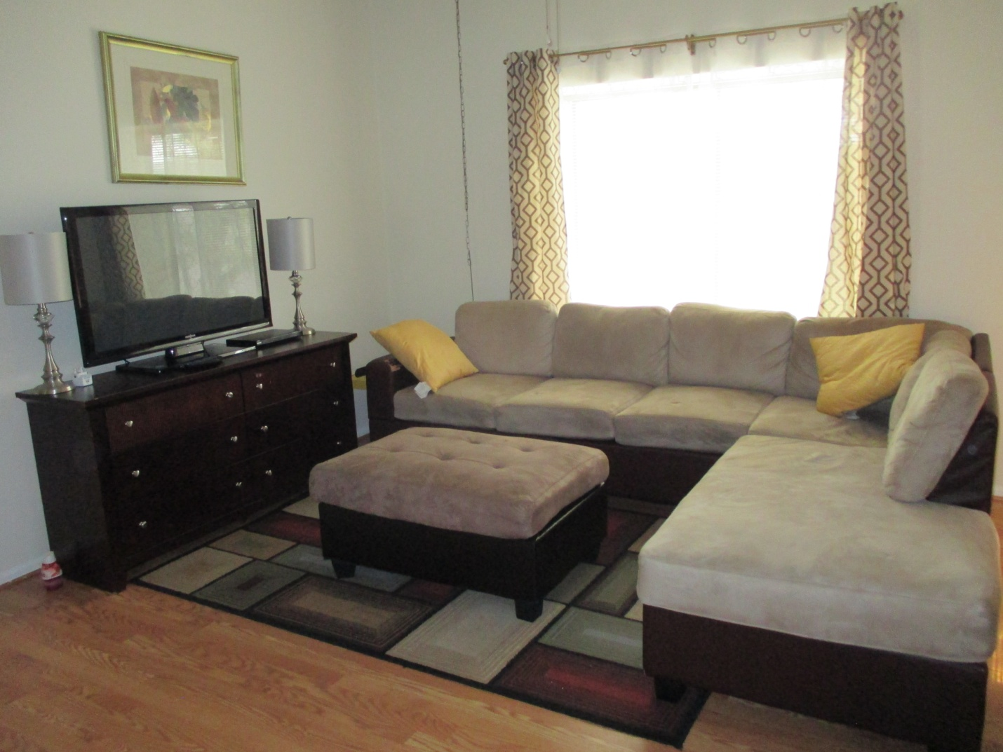

CONVENIENT LOCATION:
2-bedroom, 2-bath condo located at 2213 S. Braeswood, this condo is in view of the Texas Medical Center. MetroRail Smithlands Station is only 1 block away, and the train takes you to MD Anderson in only 1 short stop, and to Baylor and other hospitals in 2 to 3 stops
GREAT AMENITIES:
Master bedroom has a king size bed and an extra twin size bed, and secondary bedroom has a king size bed (can be set up as 2 single beds) and an extra twin size bed, comfortably accommodating 6 people. Sofa Sectional in living room can also be converted to a single bed.
All bills paid. Fully furnished, beddings and towels provided. Highspeed WiFi internet, flatscreen TV, central A/C and heating. Fully furnished kitchen with microwave. Washer/Dryer in unit. Designated covered parking. Swimming Pool on site. Gated community.
AFFORDABLE RATES: $700/week, $2,500/month for the entire condo.
STUDENT SPECIAL:
For students, interns, fellows and observers, you can rent one of the lockable bedrooms and share the common areas with another student of the same gender who occupies the other bedroom.

Each lockable room with attached bathroom rents for $1,200/month single occupancy, or $1,400/month double occupancy.

Please write or call for availability. Email: dr.davidchan@yahoo.com Phone: 1-713-302-6122
We operate multiple 1-bedroom and 2-bedroom units, all in the TMC bedroom communities. We can match your dates with suitable and available accommodation.

